Adding and Changing Content
When selecting a folder in the folder tree, you will see a ‘folder’ menu appear. When you have ADD permission on this folder you will get the menu item ‘New’ with submenus for a new file, folder or hyperlink. These menu items take you to the add/edit screens. Alternatively you can get to this by right-clicking an item and selecting ‘Edit Attributes …’ or ‘New Version …’.
The system distinguishes between 3 basic primitives: a file, a folder and a hyperlink. The difference is what is stored in DMX. Selecting New File will bring up an upload screen. The New Folder option takes you straight to the Metadata screen as there is nothing to upload. Finally the New Hyperlink brings up the familiar DNN url select control.

General
Depending on your configuration you’ll either see a wizard-style interface taking you through 3 or more steps to create your new entry or you’ll see a the creation process as a two-step process so the screenshots in this document may differ from what you’re seeing. Regardless of this you’ll see an upload panel first if you’re uploading content. This upload panel is configurable so the screenshots can also differ in this respect.

Upload
If you’ve opted to create a new (or new version of a) file then you’ll first need to upload new content. For creation of new files you may select multiple files at once.
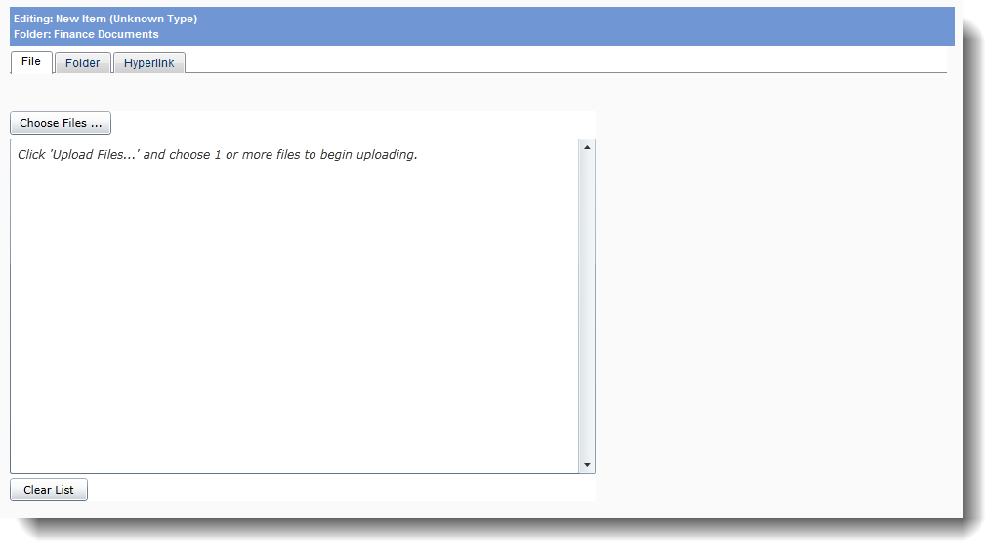
Once the files have been uploaded click “Next”

Core Metadata
This is where you specify the core attributes of the item.
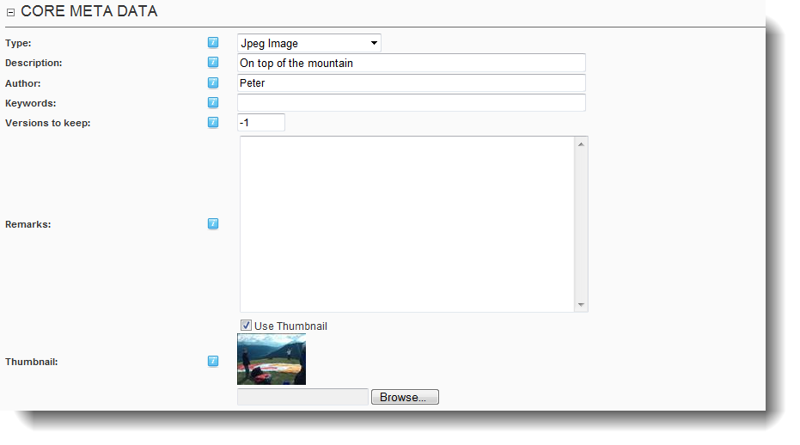

Type
Normally you won’t need to alter this. In case of a file upload it shows the detected file type. Otherwise it will remain on ‘folder’ or ‘hyperlink’. This property is used in extensions that use so-called custom types. It is also used to tell the browser what kind of content this is when you download the file (i.e. the so-called mime-type).

Description/Title
The title of the item. It is a required field.
NOTE: this is a multilingual field. If you install multiple languages, you will have the option to give content a title in each installed language.

Keywords
It is up to you how you wish to use this field. It is currently not used any other way than as a text-field you can search in later.

Versions to keep
Any item can have multiple versions. Here you specify how many should be kept in DMX. Older versions will get deleted upon maintenance. If you specify ‘-1’ here, all versions will be kept.

Thumbnail
If the item was an image DMX will have generated a thumbnail of it. Either way you can opt to upload an image file to use as thumbnail. The settings for the thumbnail are in the Main Options of the module.

Permissions
By default the permissions are inherited from the parent and pre-filled into the control. The control resembles the regular DNN permission grid control used throughout the framework and supports Role Groups and the addition of users.
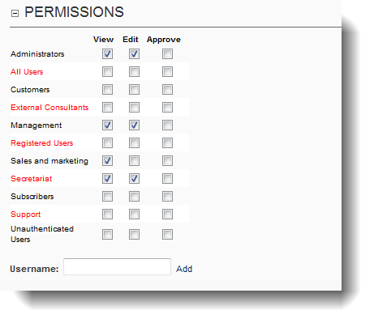
Each permission type is also subject to its own permissions, meaning that only administrators can set ‘approval’ permissions. In the default installation there are 4 permission types:
- VIEW
- EDIT
- ADD (only on collections)
- APPROVE (only on files)
Not all permission columns may show up. ADD will not show up on File or Hyperlink types. They may also not all be selectable. This is governed by the Permission permission settings in the Main Options section.
NOTE: this panel is not visible if the administrator has specified only administrators can set permissions in the DMX options.

Categories
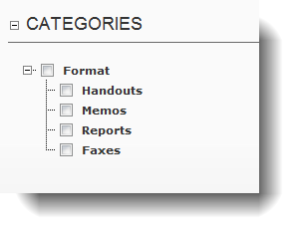
The categories are shown in a treeview checkbox list. The “root category” setting under the module’s settings governs where this starts/which categories are displayed.
NOTE: this panel is invisible if no categories are specified in the portal

